Epic Innovators Group Assignment

Patrick Mamigonian (s3858848)

Adam Wilkinson (s3851547)

Patrick Jenner (s3831040)

Jay Hunter (s3855709)

Jacob King (s3858820)

Table of Contents

Personal Information 4

Jay Hunter 4

Adam Wilkinson 4

Jacob King 5

Patrick Mamigonian 5

Patrick Jenner 7

Team Profile 8

Jay Hunter 8

Adam Wilkinson 8

Jacob King 8

Patrick Mamigonian 8

Patrick Jenner 9

Ideal Jobs 9

Crossover between these jobs 10

Differences 10

Tools 11

Industry Data 12

Job Titles and Ranks 12

Adam W. – System Administrator. 12

Patrick M. – Chief Information Officer. 12

Patrick J. –Database Analyst. 12

Jay H. – System Engineer. 13

Jacob K. – Software Engineer 13

Generic & IT-specific Skills Ranks 13

IT-Specific Skills 14

IT Work 15

Interview – Max Mikhael, Systems Manager – Outotec Pty. Ltd. 15

Please tell us about your IT work. What exactly do you do? 15

2. Please tell us about the industry you work in. 15

3. What other kinds of work do you have to do? 16

4. Who are all the different people you interact with in your work? Please tell us about them. 16

5. Please tell us about your interactions with other IT professionals. 17

6. What about your interactions with clients or investors? 17

7. What aspects of your work do you spend most time on? Please tell us about these. 17

8. Which aspects of your work do you find most challenging? 17

9. Finally, can you share an example of the work you do that best captures the essence of the IT industry? 18

IT Technologies 19

Robots 19

What does it do? 19

What is the likely impact? 20

How will this affect you? 21

Blockchain & Cryptocurrencies 22

What does it do? 22

What is the likely impact? 24

How will this affect you? 25

Autonomous Vehicles 27

What does it do? 27

What is the likely impact? 28

How will this affect you? 29

Cyber Security 30

What does it do? 30

What is the likely impact? 31

Project Ideas 33

Overview: 33

Motivation: 33

Proposal: 33

Resources: 34

Outcomes: 34

Group Reflection 36

Adam Wilkinson 37

Patrick Mamigonian 37

Jacob King 37

Jay Hunter 38

Patrick Jenner 38

References by Section 39

Project Bibliography 39

Robot Bibliography **Error! Bookmark not defined.**

Blockchain & Cryptocurrencies Bibliography 40

Autonomous Vehicles Bibliography **Error! Bookmark not defined.**

Cyber Security Bibliography 41

# Personal Information

## Jay Hunter

I am Jay Hunter, student number S3855709, I am 22-years old working as a Pharmacy Assistant in Brisbane. In my free time I enjoy reading articles on medical technology and computer engineering, reading books on history and philosophy, and playing guitar. Next year, I will be studying Computer Engineering at the University of Queensland majoring in Image and Pattern Recognition and High-Performance Computing. Currently I have no professional experience in IT, only enthusiast projects and research.

## Adam Wilkinson

The “Myer-Briggs” style test has me listed as a virtuoso tagged as wanting to explore and always seeking improvement. The categorised sections have me consistent down the middle in all parts. The learning style quiz shows that I am a visual learner. The suitable job test lists a variety of jobs with a common theme of production and jobs that would require problem solving. These attributes mean that when put into a team environment I am always wanting to learn and develop from the knowledge and experience of my group. When they show me a better way of achieving an outcome it will better my work which will result in a better contribution to the group.

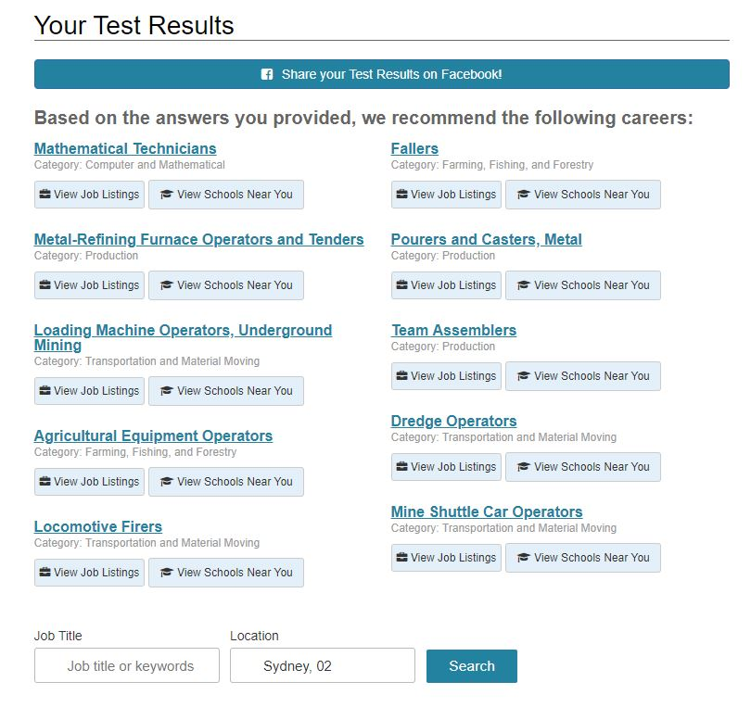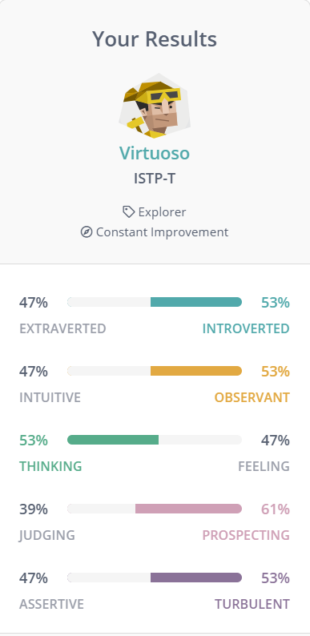

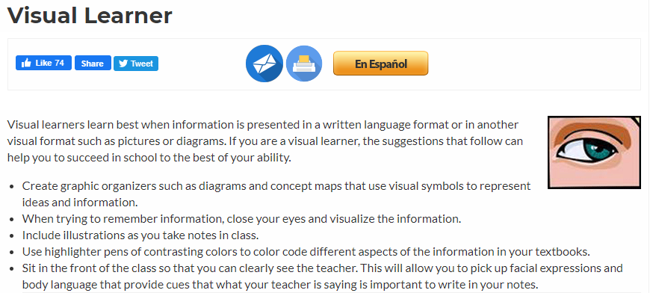

## Jacob King

The personality type INTP will be blunt and direct, approaching problems head on and focused, meaning less time will be spent on chit-chat. INTP personality types are imaginative and original, always striving to a solution to the problem at hand. Another strength of the INTP is their objectiveness. These strengths all collaborate to keep the INTP personality on task and by extension, the group as well. My result for learning style was tactile/kinesthetic. This means that I learn best with hands on activities, taking things apart and putting them back together again. If this were code, then it would be best for me to take it step by step, disassembling and seeing how it works. Communicating how someone’s code works is best communicated to me in this way. The final test was a career insight test, and I got careers that revolve around logic and mathematics.

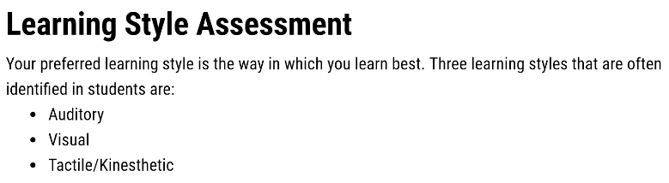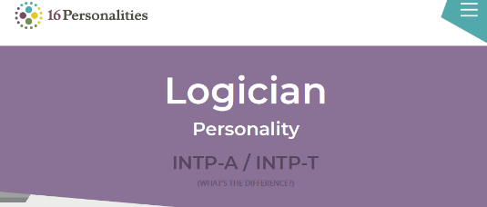

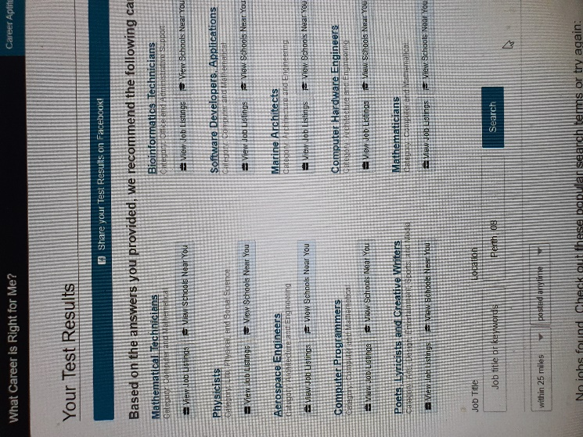

## Patrick Mamigonian

Some of the terms the online tests have used to describe my personality are ‘The Guardian’ and ‘The Protagonist”. While these are broad categories, they contained elements of confidence, influential, leadership and altruistic. I was particularly pleased to see this one statement “*Protagonists take a great deal of pride and joy in guiding others to work together to improve themselves and their community.*” which I feel encompasses my deeper motivations. On the other hand, the assessment of my weaknesses was equally accurate, in describing me as overly idealistic and overly selfless, which can result in being spread too thin.

In a team environment there are a few elements of my characteristics that I need to be self-aware. The personality tests accurately indicate that I may like to lead the charge, be overly optimistic of achievable outcomes and place high expectations on members. This may be my psychological dominance, however over time I have become well conscious of these self attributes, and become a more effective team member, often encouraging others to take lead roles, and being a more facilitating leader.

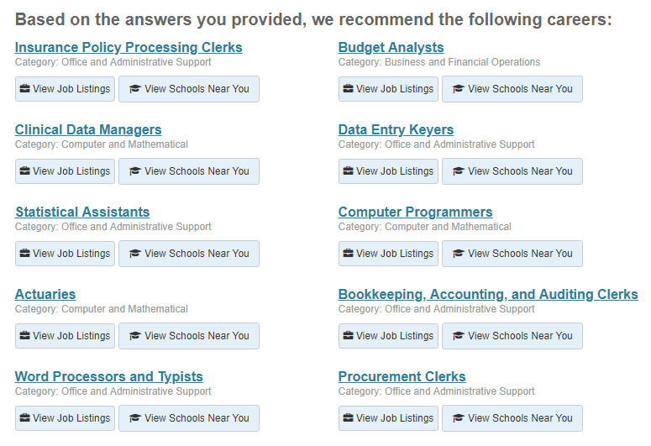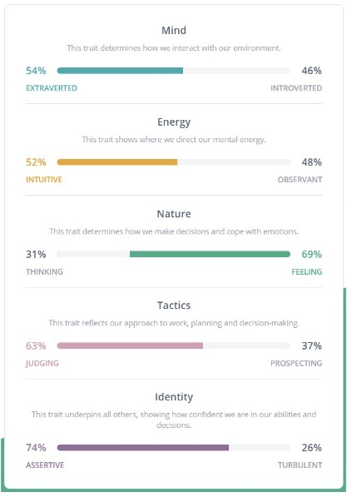



## Patrick Jenner

Results show that I am a visual learner, a INFP, and would suit careers revolving around technical thinking like Statisticians, Physicists, and Computer Programmers.

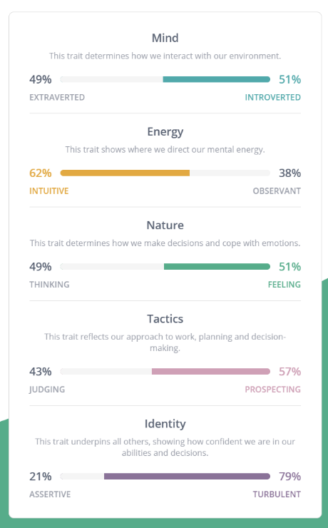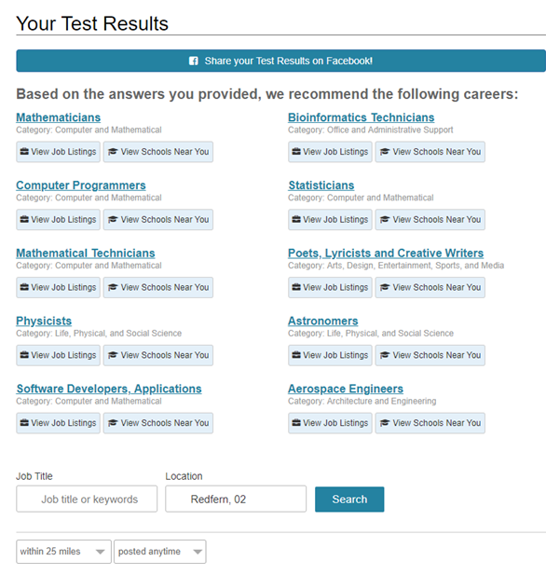

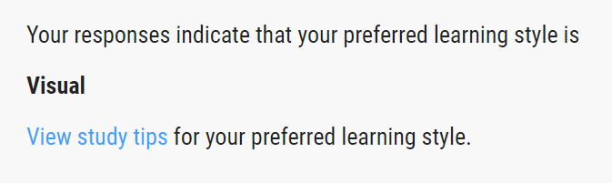

# Team Profile

Team Name: Epic Innovators

## Jay Hunter

I am Jay Hunter, student number S3855709, I am 22-years old working as a Pharmacy Assistant in Brisbane. In my free time I enjoy reading articles on medical technology and computer engineering, reading books on history and philosophy, and playing guitar. Next year, I will be studying Computer Engineering at the University of Queensland majoring in Image and Pattern Recognition and High-Performance Computing. Currently I have no professional experience in IT, only enthusiast projects and research.

Jay’s three tests were *Myers-Briggs*, *Learning Type*, and a *Career Aptitude* test which categorised him as ENFP, a Visual Learner, and the following careers: Remote Sensing Technician, Timing Device Assembler and Adjuster, Computer-Controlled Machine Tool Operator. Using this information, Jay can communicate effectively with the group and work on any task given without dissent. Being a visual learner, he may be able to provide useful graphics or styling ideas for the group.

## Adam Wilkinson

The “Myer-Briggs” style test has me listed as a virtuoso tagged as wanting to explore and always seeking improvement. The categorised sections have me consistent down the middle in all parts. The learning style quiz shows that I am a visual learner. The suitable job test lists a variety of jobs with a common theme of production and jobs that would require problem solving. These attributes mean that when put into a team environment I am always wanting to learn and develop from the knowledge and experience of my group. When they show me a better way of achieving an outcome it will better my work which will result in a better contribution to the group.

## Jacob King

The personality type INTP will be blunt and direct, approaching problems head on and focused, meaning less time will be spent on chit-chat. INTP personality types are imaginative and original, always striving to a solution to the problem at hand. Another strength of the INTP is their objectiveness. These strengths all collaborate to keep the INTP personality on task and by extension, the group as well. My result for learning style was tactile/kinesthetic. This means that I learn best with hands on activities, taking things apart and putting them back together again. If this were code, then it would be best for me to take it step by step, disassembling and seeing how it works. Communicating how someone’s code works is best communicated to me in this way. The final test was a career insight test, and I got careers that revolve around logic and mathematics.

## Patrick Mamigonian

Some of the terms the online tests have used to describe my personality are ‘The Guardian’ and ‘The Protagonist”. While these are broad categories, they contained elements of confidence, influential, leadership and altruistic. I was particularly pleased to see this one statement “*Protagonists take a great deal of pride and joy in guiding others to work together to improve themselves and their community.*” which I feel encompasses my deeper motivations. On the other hand, the assessment of my weaknesses was equally accurate, in describing me as overly idealistic and overly selfless, which can result in being spread too thin.

In a team environment there are a few elements of my characteristics that I need to be self-aware. The personality tests accurately indicate that I may like to lead the charge, be overly optimistic of achievable outcomes and place high expectations on members. This may be my psychological dominance, however over time I have become well conscious of these self attributes, and become a more effective team member, often encouraging others to take lead roles, and being a more facilitating leader.

## Patrick Jenner

Results show that I am a visual learner, a INFP, and would suit careers revolving around technical thinking like Statisticians, Physicists, and Computer Programmers.

## Ideal Jobs

Each of us has a different area of interest in the IT area. Below I’ve listed the points about the crossovers and difference between these roles

[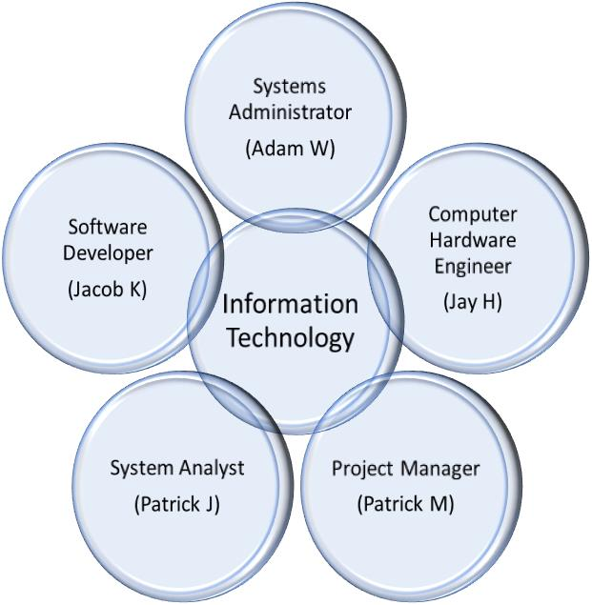](https://as-prod.asyncgw.teams.microsoft.com/v1/objects/0-sa-d6-998b5971972e6eced86f5ede75b20776/views/imgo)

### Crossover between these jobs

* All involve collaboration between people of different disciplines
* Each role involves it’s own form of problem solving
* They all involve sold communication
* Understanding other IT disciplines

### Differences

* But each involves different skills
* Different technical disciplines
* Different balance general understanding and technical understanding
* Different roles and challenges

# Tools

This is our team website for our group Epic Innovators. It will grow and change as we continue and begin to develop our project idea outlined in our assignment 2 report. It shows some information about each of the team members and gives a link to their individual website to show more about them and their interests and ideas about the IT world.

Links:

[Team Repository GitHub](https://github.com/Gitstar2020/ITT-G21-Assign2)

[Team Website](https://therealadz.github.io/EpicInnovators/)

# Industry Data

## Job Titles and Ranks

The following ranks are from a Burning Glass Technologies report showing the job landscape of the IT industry in Australia and New Zealand over a 1-year period ranging from 24/03/2017 to 23/03/2018 and have used data from 120353 postings.

Where an appropriate job title could not be located in the study a current job search using [www.seek.com.au](http://www.seek.com.au) has been used and added to everyone else to add context. The data from seek is however very different to that of the Burning Glass as it only captures current vacancies from the last 30 days from day of writing (17/04/2020). Also, many jobs overlap across job titles as well as 1 vacancy being advertised by multiple recruitment agencies.

### Adam W. – System Administrator.

System Administrator ranks at number 8 out of 25 on the list with 681 jobs listed in the 1-year time frame that the Burning Glass data shows. [Seek](https://www.seek.com.au/system-administrator-jobs?daterange=31) displays that across Australia there are currently 1325 active job vacancies as of 17/04/2020.

Having looked at both the Burning Glass data and Seek my choice of System Administrator has not changed. The job appealed to me because of the service it was delivering as well as the skills that are required as ones which I hope one day to possess. My ideal job requires skills that rank at the top of the Generic & IT-specific skills. The job title itself ranks in the upper third of the list meaning there is an availability of jobs. The data itself has only reinforced my original choice of System Administrator as an ideal job.

### Patrick M. – Chief Information Officer.

The job in the Burning Glass data which most accurately reflects Patrick M’s job is that of a Service Delivery Manager. It ranks at number 18 out of 25 with 338 jobs listed. [Seek](https://www.seek.com.au/chief-information-officer-jobs?daterange=31) shows that across Australia there are currently 377 active job vacancies as of 17/04/2020.

There are clearly less positions advertised in my desired role compared with other roles and this is as expected. There are however opportunities in small to medium organizations that I feel confident of having good prospect of candidacy and, given the opportunity, would have the experience to successfully fulfill.  The challenge is since the pandemic event, with recruitment freezes and cost reduction exercises now in effect across almost every organization, these higher roles may now become scarce and competitive. In this case I would need to adapt, re-evaluate, and up skill for another role. At this stage of my career however that would be a daunting prospect.

### Patrick J. –Database Analyst.

The Burning Glass data does not provide an accurate job role for that of a Database Analyst. [Seek](https://www.seek.com.au/database-analyst-jobs?daterange=31) displays that across Australia there are currently 228 active job vacancies as of 17/04/2020. I’ve chosen this role because it employs a range of different disciplines and involves a lot of problem solving. The Burning Glass data does not provide an accurate job role for that of a Database Analyst. I found it on [Seek](https://www.seek.com.au/systems-analyst-jobs-in-information-communication-technology?daterange=31&sortmode=ListedDate).

### Jay H. – System Engineer.

The job in the Burning Glass data which most accurately reflects Jay’s job is that of a Systems Engineer. It ranks at number 4 out of 25 with 786 jobs listed. [Seek](https://www.seek.com.au/systems-engineer-jobs?daterange=31) shows that across Australia there are currently 5318 active job vacancies as of 17/04/2020.

Observing the Burning Glass Data, I was taken aback at the top IT titles in Australia. After looking through the list I still want to become a Computer Engineer, I may need to look at working in another country. Communication skills and problem solving ranking the two top baseline skills was no shock. No matter the project communication between co-workers and clients is key to moving forward. Resolving issues in large projects requires problem solvers who can communicate with one another.

### Jacob K. – Software Engineer

Software Developer ranks 19 out of 25 on the list with 337 jobs listed on the report. [Seek](https://www.seek.com.au/software-developer-jobs?daterange=31) shows that across Australia there are currently 3652 active job vacancies for a Software Developer as of 17/04/2020.

My ideal job has changed. The one I selected originally was in a software development roll, and the one I now want to have is software engineer. There are more jobs for a software engineer than software developer, and further researching the roll of both, software engineering appeals to me more. A software engineer is required to develop a solution to a software problem, maintain, test and evaluate software whereas a software developer builds that same software.

## Generic & IT-specific Skills Ranks

**Generic Skills -** The following ranks are from a Burning Glass Technologies report showing the baseline (generic) skills in the greatest demand in the Australian and New Zealand IT industry. They capture a period from 01/03/2017 to 28/02/2018 and have used data from 121997 postings with 25 generic skill set filters applied.

Across all 5 of the ideal jobs there are 3 recurring **generic** skills that appear to be the most sort after. These make up out group’s required generic skill set. They fall under the categories of *Communication Skills, Teamwork/Collaboration* and *Problem Solving*.

***Communication Skills:*** This is ranked number 1 out of 25 on the list with 44367 postings requiring it as a generic skill for the position.

***Teamwork/Collaboration:*** This is ranked 5 out of 25 on the list with 14364 postings requiring it as a generic skill for the position.

***Problem Solving:*** This is ranked 2 out of 25 on the list with 16445 postings requiring it as a generic skill for the position.

The 3 highest generic skills that are not in our groups required skill set are *Organisational Skills, Writing* and *Troubleshooting.*

## IT-Specific Skills

The following ranks are from a Burning Glass Technologies report showing the specialized (IT-specific) skills in the greatest demand in the Australian and New Zealand IT industry/ They capture a period from 24/12/2017 to 21/03/2018 and have used data from 27435 postings with 25 IT-specific skill set filters applied.

Across all 5 of the ideal jobs there are 3 recurring **IT-specific** skills which are required the most. They fall under the categories of *SQL, Microsoft Windows* and *Microsoft C#*.

***SQL:*** This is ranked number 1 out of 25 on the list with 3570 postings listing it as a required skill for the position.

***Microsoft Windows:*** This is ranked 4 out of 25 on the list with 2699 postings listing it as a required skill for the position.

***Microsoft C#:*** This is ranked 12 out of 25 on the list with 1643 postings listing it as a required skill for the position.

The 3 highest IT-specific skills that are not in out groups required skill set are *JavaScript, JAVA* and *Project Management.*

# IT Work

## Interview – Max Mikhael, Systems Manager – Outotec Pty. Ltd.

### Please tell us about your IT work. What exactly do you do?

I am primarily responsible for the network and server infrastructure of the company’s South East Asia Pacific region. This includes network connections, network devices, servers, storage, and data centre facilities.

There are 3 primary data centres located in Sydney, Melbourne and Perth containing a total of around 90 servers that host the various systems and applications used by the business.  The majority of servers are Windows based with some Unix variants.  I’m responsible for managing, maintaining, monitoring health, utilisation, alerts, and also backup systems. I am also responsible for maintaining server operating systems, patches and security updates, and also virus and threat protection.  Nearly all servers are virtualised using VMWare and this provides the ability to maximise the use of physical hardware by loading multiple virtual servers on each physical machine. Virtualisation saves cost by reducing the number of servers that need to be purchased and maintained, and also saves energy and space in our data centres. VMware also provides the flexibility to easily attach and expand storage and move virtual servers around between different data centres.

Some of the systems and applications running on the servers include Domain Controllers, File and Printer Sharing, Web Servers, Terminal Servers, Document Management Systems, CAD Design Applications, HR and Payroll systems, Project Management, Resource Management, and Relational Databases. Some other business applications such as ERP and CRM are hosted externally or in the cloud and I have some involvement with those also, but they are primarily managed by providers.

### 2. Please tell us about the industry you work in.

I work in the mining and manufacturing industry. The company has around 20 offices across Australia and South East Asia with around 500 employees.

The company consists mainly of engineers, CAD designers, project managers and service technicians. The company designs machinery that it manufactures and delivers to customers; which are mainly mine sites in remote regions of Australia and Asia Pacific. The business also has a large sales team, after-sales spare parts, services, and business support teams including ICT, Finance, HR, Quality, and EHS.

The employees are heavy travellers, such as the sales team who travel to meet with customers, and project managers and service technicians that regularly travel to mine sites to inspect and maintain equipment. People rely heavily on ICT services to operate as mines run 24x7.

### 3. What other kinds of work do you have to do?

I will often have projects or work with a particular project team in planning to deploy a new system, application, or upgrade an existing one. This requires scoping of the system requirements, looking at the architecture of the application whether it is web-based, thin/thick client, if it has a central database, if data can replicate across multiple sites, and so on. Then decide and plan how and where best to host the application to provide optimal performance for the end-users.

From time to time we need to relocate one of our offices containing a data centre and that requires planning and execution which can run 9-12 months. Other times our company will acquire another company and integrating systems can sometimes take years in addition to our existing duties.

### 4. Who are all the different people you interact with in your work? Please tell us about them.

I interact with many different teams and individuals:

* ServiceDesk team who are first line support and escalate issues to me for investigation.
* Other systems administrators in my team, I’m based in Sydney as the manager and others are located in Perth and Melbourne.
* Information Security team that are based in our HQ and responsible for entire global IT security, firewalls, VPN tunnels, and also SIEM (security incident and event management).
* Infrastructure team that are based in our HQ and responsible for global Active Directory, data routing and other standards.
* Application service managers that are responsible for major business applications, such as ERP, CRM, PDM (Product Data Management), etc.
* Vendors such as Telstra and others that provide our data connections to various sites, also external application vendors to assist with troubleshooting an issue or performing an upgrade.
* My manager and team to keep each other updated on what is happening and share thoughts and experiences.
* Other teams or departments in planning to deploy/upgrade an application as mentioned previously.

### 5. Please tell us about your interactions with other IT professionals.

As mentioned above:

* Other systems administrators in planning and executing tasks and projects
* Information security specialists in discussing and implementing security systems and measures
* Infrastructure specialists in discussing and implementing new network systems and changes
* Cloud services specialists in setting up and troubleshooting cloud based services
* Application specialists in deploying/upgrading and troubleshooting various applications.

### 6. What about your interactions with clients or investors?

My clients and investors are internal to the business. In a corporate environment investors are senior executives and key stakeholders that need to provide financial outcomes for the business. Ultimately my customers are end-users although I mostly work behind the scenes and customers are filtered through Service Desk.

### 7. What aspects of your work do you spend most time on? Please tell us about these.

Projects such as new systems/application implementations as mentioned earlier can take months of work.

For the past couple of years we have been working heavily on upgrading servers that are running Windows 2008R2 to later versions of Windows Server such as 2016 (due to Win Server 2008R2 reaching end of support on Jan2020). This requires quite some effort and working alongside application owners. We often build up parallel environments, perform testing of the system, then migrate data and it can take some time and effort for each system and application.

Some applications can also be somewhat high-maintenance and time consuming to maintain. They can be unreliable, tend to freeze up or have bugs. We put up with it because the business needs that application and there aren’t many alternative solutions available, or the business has invested a significant amount in the application however it never performed as reliably as expected even after years of fine tuning. We therefore deal with daily issues and manage it as best as we can until an alternative solution becomes available in the future.

Site relocations as mentioned earlier can consume almost a year in planning and execution; we recently relocated the Sydney site in 2018.

### 8. Which aspects of your work do you find most challenging?

Troubleshooting problems can be challenging, where an application or system starts to behave abnormally, becomes slow to access or completely inaccessible for some or all users.  In most cases nothing has changed to our knowledge. It can be anything from a data corruption to a routing issue to anti-virus software blocking some communication.

The past few years with everything moving to the cloud we are finding new challenges such as Windows/Office updates coming more frequently and seamlessly, they can often be the silent cause of a problem. Cloud service providers from time to time will also change a configuration which we are unaware and later discover requires changes to our firewall rules, it can sometimes cause many hours or even a full days of downtime for a particular system.

Some other challenges are finding time to maintain documentation and managing the ever growing storage requirements of the business.

### 9. Finally, can you share an example of the work you do that best captures the essence of the IT industry?

The essence of the IT industry in my opinion is the constant development of technology by a large community of specialists. My line of work is to identify which of those new and emerging technologies can benefit the business where I work by introducing efficiencies, streamlining and adding value.

In more recent years the IT industry's focus has turned to managing privacy and security, and the threats are both from outside and within the industry.  The development of advanced threats such as ransomware and other exploits are expected from malicious hackers and manageable to some extent, while privacy compromise is often the result of personal information gathering and exploitation by technology companies themselves, and this is a significantly more challenging threat to manage.  It brings into question the ethics of some sectors of the IT industry, and if left unaddressed, will harm the fundamental essence of the industry.

# IT Technologies

## Robots

### What does it do?

There is currently a vast array of new developments going on in the world of robotics, but the underlying goals are very similar. It is all about applying mechanical problem solving to real world working environments. Given the broad nature of the topic, There are two significant developments: Soft robotics and Collaborative robots.

Soft robotics take advantage of the mechanism of organisms and aim to emulate them in a non-rigid way by using materials with the properties of living tissue (e.g.; stretches and squashes rather than pivots). Currently soft robots use fluids such as air pumped into small pockets which expand under pressure similar to balloon inflating and deflating. Via stiffening part of the material, the machine can be made to move in a particular direction, similar to the motion of an actuator or piston. (François Schmitt, 2018)

Soft robots are typically created via an additive process (e.g.; adding material to a mould, rather than cutting it down). Soft robots can distribute force evenly across the surface. This enables ‘off the shelf’ solutions such an FDM 3D printing to be used in the manufacturing process reducing costs. (Dylan Drotman, 2019)Advances are being made in the design of the robots so that one single tube of compressed air can be used to power multiple motions.

The applications for Soft Robots are vast, ranging from climbing robots to wearable robots but the most significant developments will be in the biomedical field. Soft robots enable a surgeon to operate in a manner that reduces trauma and pain due to their non rigid nature. Soft robots can pickup more fragile objects without the use of sensors and complex mechanical parts. (Team, Robotics Online Marketing, 2018) (Runciman, Mark; Darzi, Ara; Mylonas, P., 2019)

Collaborative robots known as Cobots, are robots that can work in conjunction with human workers. Robots in the workplace, do their work fenced away from human workers due to safety issues such as collisions/impacts (robots hitting people), but Cobots have an array of sensors which enable them to work alongside human workers. This allows for the human workers to guide the robots through a particular task rather than go through the rigours of complex robotic programming which means that lower skilled human workers can setup the Cobots to perform a new task quickly. (Zimmermann, 2019)

Robots today, are more suited to doing monotonous repetitive tasks that a person would do less precisely or which could injure or endanger humans if they were to perform that particular task. The advent of Artificial Intelligence (AI) in collaboration with sensors means that the robots are able to develop datasets from sensor data, that will enable robots to learn and improve on a task. An example could be an object which isn’t precisely where the robot expects it to be, the AI and data will assist the robot in working out where the object will be and the robots will learn to expect it to be in that location. (Vargas, 2018)

The development of each of these systems are not mutually exclusive. They are both aiming to improve safety and assist workers in a similar capacity to a tool, rather than replace them. They both aim to use sensors to give the robot feedback on its environment.

Advancements in computing hardware such as Nanomagnetic Logic (Crawford, 2012), memory and sensors enable more complex tasks to be performed by machines at less cost and advancements in the engineering of materials enable robots to be built and constructed at lower cost. Due to these factors, robots are likely to become faster and more accurate.

Soft Robots and Cobots are ultimately advanced tools. Just as a spanner tightens a nut, these robots enable precise and repetitive tasks to be performed with ease. Soft Robots and Cobots will one day come together to provide a safer and more efficient working environment.

### What is the likely impact?

The proprietary nature of the current systems could mean that the robotics companies could hold their client’s small business to ransom. This is very much a danger associated with outsourcing outlined in Volodymyr Ostapchuk’s article; ‘Outsourcing Benefits and Ways to Mitigate Possible Risks’, Volodymyr *Ostapchuk* (2020) states that companies could potentially increase costs of their services, and this is no different with Robotics companies. Andra Picincu also mentions that should the company (in our case the robotics company) stop support of that product (robot) the company using the robot could experience a significant loss of productivity. (Picincu, 2019)

If a business were to become reliant on a particular Cobot and Soft Robot company who own the patent the demands of that company would affect the business.

When the benefits of Cobots become obvious to businesses, they will begin to appear in work warehouses and factories and Soft robots will begin to appear in many applications such as surgeries, espionage, food processing, search and rescue and manufacturing. According to Carlos Gonzalez, 34% of all Industrial robots sold will be Cobots by 2025 (Gonzalez, 2017)

Soft Robots will be used in places where a traditional robot can’t, such as the human body. Soft Robots will enable surgeries to be done more much quickly and accurately via soft robotic endoscopy (a surgical camera which can traverse the human body without doing damage), reducing the time required (Mark Runciman, Ara Darzi, and George P. Mylonas - 2019).

Soft Robot Search and rescue could be used in areas where the rigid robot equivalent would be more expensive. We could potentially dispose of the Soft robot if required as it would not be as expensive. (Brown, 2018)

Another application for Cobots and Soft Robots could be in the task of repairs. A robot could be designed to repair machines. The nature of the soft robots could allow for a robot to squeeze through and manoeuvre through the gears of a larger machine and reach areas difficult for human workers to access.

### How will this affect you?

3D printable designs in soft Robotics mean designs can be downloaded and created. A variant of Soft robots will become more available to hobbyists and enable people such as myself to create simple robots for performing tasks. It would be possible for a relatively cheap DIY robot kit to be created at home. (Holland, Dónal; Walsh, Conor J.; Herman, Max ; Berndt, Sara, 2018)

Due to the ability of Soft Robots to grip more fragile objects and significant application for them is food. Fewer humans in the processing chain mean that things like disease are no longer a problem. (Owen-Hill, 2017) This would mean that it’s harder to spread something such coronavirus, which would allow employees to continue work during a quarantine.

These robots could affect me in mostly in an economic way. Soft Robots Cobots could become a standard in most workplaces which require manual labour. The deployment of Cobots can increase productivity due to their ability to free human workers from repetitive tasks, meaning they can perform more human specifics tasks. (Hern, 2019) Less expensive manufacturing costs may result in Cobots result in cheaper products.

Cobots will start to appear in hospitals performing tasks such as Neurosurgery (manoeuvring a microscope to give surgeon a better view) and Bone Surgery (able to cut bone with a cold laser with no contact) (Owen-Hill, 2019). Another example of this is the da Vinci system. It allows are surgeon to perform more precise actions by capturing the hand movements of the surgeon and mimicking them with smaller robotic mechanisms. (Roberge, 2019)

Thanks to developments in 2D and 3D camera technology and AI, we may start to see robots in the home become a reality. A robot called Aeolus is designed to do all the things most people envision a household robot doing, such as house hold tasks like mopping up, sweeping vacuuming and fetching beverages (Vyas, 2018). While household robots like Aeolus don’t fit the traditional definition of a Cobot I would argue that they’re similar to a Cobot in that they free people up to do more human skill intensive tasks in that same way that Cobots do in the workplace.

In conclusion these technology aid peoples in the real world by assisting people and we can expect a more optimistic future.

## Blockchain & Cryptocurrencies

### What does it do?

In simple terms a blockchain is a data structure that acts as a ledger for transactions with each “block” containing digital pieces of information about a transaction. These include the date, time and amount of a transaction along with the participants who are identified only by a digital signature. Each block can contain a single transaction or many thousands of them. Each block stores its own unique identifying code called a “hash” that makes the block uniquely distinguishable from every other block in the chain. Only once all transactions in the block have been verified through a consensus process can a hash be added. When a new block is made it contains the hash code of the most recent block before it. This creates a link between the blocks and is the “chain” in blockchain (Reiff, 2020).

What makes a decentralised blockchain unique compared with traditional financial transactions is that it does the transactions without the use of a single trusted third party. The blockchain network instead runs on thousands of independent public computers called “miners” which all have the exact same copy of the blockchain and process transactions which update as a new block is added to the chain. This is what makes a blockchain arguably more secure than that of a centralised system such as a bank. If a malicious person attempts to manipulate a transaction this would change the hash of the block which would fail to match the hash generated by other mining computers processing the same transaction, thereby failing the consensus verification, resulting in the rogue block being discarded.

These features are only secure if the blockchain is public with the ledger of all transactions viewable to anyone who wishes to access it. If a blockchain is stored entirely on a centralised private company’s server this creates the same vulnerability to that of a traditional banking system, meaning there is a lack of transparency and the administrators of that central server have full access to manipulate transactions and alter the ledger (Biczok, 2018).

Cryptocurrencies are a form of digital currency and use blockchain technology as the backbone for tracking and managing transactions and account balances. Just as a safe or vault is used to protect government-issued cash currency (referred to herein as ‘fiat’ currency), cryptocurrencies use a form of encryption called cryptography to secure people’s accounts from hacking and theft, this is what gives the “crypto” in cryptocurrency. Using cryptography to secure transactions means cryptocurrencies are nearly impossible to counterfeit (Frankenfield, 2019).

Most cryptocurrencies work on a decentralised platform, meaning they are not controlled by a single individual, group, entity or government but operate on a public peer-to-peer basis. This concept means they can operate without the interference or influence of governments. This is partly the attraction of cryptocurrencies among people that desire independence from government control.

The first decentralised cryptocurrency created was Bitcoin in 2009 by a pseudonymous developer or group under the name Satoshi Nakamoto. This was in response to the GFC where people became sceptical about the stability of fiat currency and manipulation by governments and central banks. Bitcoin is still the largest and most widely known cryptocurrency in the world, with a current market capitalisation of US$130 Billion and dominance of around 65% relative to the combined total of all other cryptocurrencies. Other cryptocurrencies are referred to as “Altcoins”. There are now thousands of such altcoins being traded globally. The largest of the altcoins include Ethereum and Litecoin, with market capitalisation of US$20 Billion and US$3 Billion, respectively (Hunter, 2018). This can be found live at [www.coinmarketcap.com](http://www.coinmarketcap.com).

Bitcoin, Ethereum and Litecoin are referred to as “Utility” coins and can be considered as virtual currency or cryptocurrency platforms. On the other hand, altcoins are more often considered as ‘Security Tokens’ and are sold to the public through initial offerings like traditional IPO’s, where a particular company is capital raising for a particular project or vision. Both utility coins and security tokens are similarly traded on public cryptocurrency exchanges, where people gather online to trade different cryptocurrencies at market determined exchange rates.

Another type of cryptocurrency worthy of note is Stablecoins. Stablecoins were created to provide a cryptocurrency that does not have the high volatility of other cryptocurrencies. Stablecoins are aligned to an asset or group of stable assets, such as US Dollar or gold, and allow users to buy and sell them when they predict the value of cryptocurrencies will fluctuate. This is more desirable than frequently switching to and from fiat currencies, which normally attract higher commissions by exchanges, and often taxable events in many countries. The largest Stablecoin is Tether, which is backed at one-to-one ratio by USD, it has a current market capitalisation of US$6.34 Billion.

Cryptocurrencies allow users to make transactions with a degree of anonymity as only their digital signature or a pseudo username is logged in the blockchain. There is some traceability where a cryptocurrency is traded through a regulated exchange which complies with a country’s ‘know your customer’ regulations, however there are many other means of transacting that are anonymous. While Bitcoin, Ethereum and many other cryptocurrencies make signatures transparent in the blockchain, some other altcoins known as “privacy” coins, keep this detail hidden. Coins such as Monero, Dash and Zcash are favoured for private activity, tax evasion, and underworld activity and near impossible to trace back to an individual.

Cryptocurrencies are stored in a virtual wallet which contain both public and private keys which are linked. When a person sends cryptocurrency to another person, they will send it to their public key. The private key (like a password used for any account) is then used to access the wallet which had the cryptocurrency sent to it. When cryptocurrency is sent to another person’s public key, ownership of that cryptocurrency is transferred, and the transaction forever recorded in the blockchain. It similarly relates to the function of handing over physical cash to another person to put in their physical wallet, with the only difference being there is an indisputable transaction record stored of the event.

Every transaction is confirmed in the blockchain by miners and a small pre-determined fee is paid to miners for the use of their computers and energy. When making a transaction a user has the option to pay a higher fee for a faster transaction. The time of each transaction depends on the computational power and efficiency of the blockchain that the cryptocurrency is operating on; this ranges from a few seconds to a few hours. Bitcoin’s blockchain operates over millions of computers with large mining facilities located around the world usually where electricity is low cost as cryptography is energy intensive. This concept is contrastingly different to that of traditional financial institutions who can often charge significant fees on transactions, particularly international, place limitations on customers, take several days to transfer funds, and can be logistically difficult for the receiving party to obtain.

Bitcoin and other altcoins are an asset class of their own, however have been likened to assets such as gold, where there is a controlled and finite amount determined by the software code which can only be altered with the consensus of the public mining community, who have a vested interest in preserving the asset’s value. Cryptocurrency valuations can however fluctuate heavily as a result of them being unregulated and in the hands of the public, accurate forecasting and models are difficult to create as there are no fundamentals based on earnings, or other meaningful metrics. Traditional ‘pump and dump’ schemes, insider trading, and cartels are rampant in the market. Furthermore, unlike stock markets, where a sharp fall resulting from heavy sell off will trigger a trading halt, cryptocurrencies have no such mechanisms and are valued based on momentary supply and demand.

### What is the likely impact?

It is foreseeable in the future that the current format of blockchain based cryptocurrencies or a derivative of it will make its way into the mainstream. The main question is whether it takes the form of decentralised or centralised. A decentralised platform allows users the freedom to send and receive payments internationally that is not traceable or controlled by governments or other private entities.

If each country’s government were to make their own cryptocurrency and blockchain with no physical currency they would have complete oversight of every transaction made by every individual or business meaning that “cash economy” (tax-free) would cease to exist. It also raises the questions of privacy as government would use it for surveillance of its citizens.

A worldwide centralised cryptocurrency seems hard to conceive as many factors go into what makes a fiat currency operate and too many variants exist in the makeup of a country to suggest one currency could suit all, including GDP, social policies, security, politics, and so on.

It is difficult to predict if changing the financial system of a government currency to that of digital would change the level of employment in the system. As jobs would become redundant, mainly in the supply chain and protection of physical currency, new jobs would be created in the infrastructure, maintenance, and development of new blockchain and cryptocurrency. Certainly, people in jobs earning non-declared income, who may otherwise be unemployable due to regulations, would be impacted. This may in some cases lead to increased crime, mental health and wellbeing issues, and dependency on social welfare as those people struggle to survive. Tax revenue may increase as evasion becomes more difficult, which would then cover the increased government social assistance, however the social wellbeing impacts may become of greater concern than economic.

### How will this affect you?

While it is unlikely that any of the currently known cryptocurrencies will become mainstream and replace government currencies, central banks and governments have expressed concerns that high uptake of some emerging cryptocurrencies from prominent organisations, such as Facebook’s Libra currently under development, could destabilise established financial and banking systems (Telford, 2019).Many countries therefore initially attempted banning the trading and ownership of cryptocurrency, however most have since relaxed policy attempting instead to regulate and force public declaration for taxation purposes.

In some countries such as Venezuela with political and financial instability, cryptocurrencies have been a saving grace for some citizens, where they have exchanged their devaluing fiat currency for Bitcoin and other altcoins. Some people escaping war ravaged countries have also successfully taken their finances out of the country by exchanging into cryptocurrency, then back to fiat currency after arriving at their destination (Salvo, 2019).

Decentralised cryptocurrencies and their use cases will therefore likely continue to evolve and develop, particularly in user interface, and will always have their place in society. As we have seen in recent years with futures trading of Bitcoin, more and more people and institutions will start to invest in them which in-turn will generate greater interest and investment over time. Awareness and education would be paramount otherwise many investors may lose significant proportions of their life earnings through innovative cybercrime or simply the volatility associated with decentralised and unregulated currency. These sorts of reasons are why the general public are currently apprehensive about cryptocurrencies becoming the normal way of paying for items. Individuals need the security of knowing then when they go to sleep at night that the amount of money in their wallet will still be worth the same when they wake up in the morning.

Discussion of cashless society has also recently emerged with the novel coronavirus pandemic possibly being spread through handling of cash, and we may see this argument leveraged by governments in the near future as an opportunity to progress cashless society with introduction of government digital currency.

While the prospect of cashless society is attractive for governments in making underworld crime and corruption more difficult, moving to digital currency could impact a significant proportion of the population that rely on cash. Sectors such as hospitality/restaurant workers that rely on tips, personal services that rely on privacy, charities and homeless who ask for money on the street, the elderly and intellectually impaired that struggle with technology would all be affected. Also small retailers that currently operate on cash to avoid electronic payment processing fees would face increased overheads (Dawson, 2017).

Other affects may be positive such as new jobs as governments and private sector look for opportunities to capitalise on the technology, new uses cases appear such as digital finance and investments. For example, in future we may see contract settlements handled with cryptocurrency ‘smart’ contracts, decentralising control, and removing any party’s ability to renege.

The true effect of all this on an individual in the future will most likely come down to deciding how much of their wealth and finances to store where, which will be a trade-off of privacy using a government backed blockchain, and cryptocurrency where people have independent control and oversight, while subject to volatile markets and fluctuation.

## Autonomous Vehicles

### What does it do?

Autonomous vehicles drive and navigate themselves. Autonomous cars drive people to their destination on the best possible route accounting for current traffic and roadworks. Also, other than cars on the road, trucks can do the same with the freight they carry. Aerial drones can make personal, smaller scale deliveries, be it for food or mail. In essence, autonomous vehicles move things around without any direct human control. All decision making is done by the vehicle or the network the machine is part of. State of the art autonomous road vehicles avoid collisions with pedestrians and other road vehicles with greater success than their human counterparts. Autonomous vehicles do not suffer any of the human impairments such as tiredness or driving under the influence. State of the art vehicles have better and faster judgment than humans would in any given situation. Emergency services can also be taken to the area they are needed by autonomous vehicles. Freight, public transport, personal transport can all be replaced with autonomous vehicles (MIT Technology Review, 2019).

Autonomous vehicles are being used in automated warehouses to sort items into containers for shoppers who ordered them. This removes the need for human workers to do the same thing, who would only be much slower and make mistakes. This technology is much like a traditional shop but instead of human shoppers, the packing of goods is done by machines.

There are self-driving cars on the road now, but with people still behind the wheel in case of emergencies. This automation technology can also be used to make self-driving trucks. This will only work on the main roads, and not in the delivery dock of warehouses and shops, so human control is still necessary. This will significantly decrease drive fatigue or could be used in conjunction with drivers to keep the truck moving even when the driver is sleeping.

Uber Eats is currently using aerial autonomous vehicles to transport food to people. This same technology can be used to deliver mail and packages instead of traditional postal services and couriers. Automating the delivery will also on the time it takes deliver packages, especially for short distance postage (MIT Technology Review, 2019).

Development of self-driving cars is being made aimed at decreasing the severity of collisions. Improvements on pedestrian detection and avoidance are being made, soon self-driving cars are likely to be better drivers than humans, and possibly even match the number of human drivers on the road. Packages to retrofit traditional cars can be made, lowering the cost of self-driving cars. Self-driving cars can also make road travel more accessible to disabled people who depend on mobility equipment, letting them be more self-sufficient.

The postal service could implement autonomous transport of packages and mail using existing technology. This will likely be a mixture of small autonomous aerial craft and self-driving vehicles. Some human interaction is still required to load and unload the packages to the person’s house, but the transportation can be done without any human interaction (N.Senerb, 2017).

Technologies that made autonomous road vehicles possible are cameras, network infrastructure, sensor technologies such as lidar and radar, AI and laser light radar. All of these work together for the vehicle to gather information on it’s surroundings and then process that information to travel without collisions. AI interprets the data these instruments gather. Network infrastructure lets these vehicles communicate to work together, further reducing collisions with other autonomous vehicles. This also allows for the vehicle to gather data on its surroundings such as speed limit and traffic lights. Sensors allow for greater situational awareness (MIT Technology Review, 2019) (Bowles, 2020).

Technologies that make warehouse automated vehicles possible are AI to organise and manage all the vehicles to keep them working cohesively together and to automate the process. Automated guided vehicles are required to move the inventory around the warehouse – these follow a set path and have additional sensors to avoid manually controlled vehicles. Autonomous mobile robots are like Automated guided vehicles however they rely on sensors and have no set path to take. These vehicles use sensors and AI to understand their surroundings. Drones use the same technology as Autonomous Mobile Robots and using GPS technology they can be used in long distance deliveries (MIT Technology Review, 2019).

### What is the likely impact?

The impact of this technology is mainly on the general public, as autonomous vehicles make transportation far more convenient. With more self-driving cars on the road, there will be significantly less crashes and fatalities will be lower. Autonomous vehicles are also more efficient drivers than humans, lowering the overall traffic on the road. This makes being on the road safer and more convenient. Public transportation could have a network of autonomous vehicles that operate much like taxis. In order to have vehicle sharing capabilities cities will need space and infrastructure to accommodate this. Passenger loading areas or on street parking is required to increase turnover. With vehicle sharing parking plans will be altered. With less cars in idle, there will be less need for parking spaces. This means more land for buildings, increasing population densities in cities. Most people (59% according to Transportation Research Procedia) who currently own cars for personal transport would rather have their own autonomous vehicle than just use one. Once there are a significant number of autonomous vehicles on the road this is likely to change as the cost of using one will be much lower than owning one. Less people will want to own an autonomous vehicle for personal transportation. With autonomous vehicles transporting goods, postage and freight hauling will take less time and cost less (The Department of Infrastructure, Transport, Regional Development and Communications, 2019).

People with mobility, and people with conditions that disallow driving such as epileptics, issues are most affected by this technology. They will be less dependent on caregivers for transportation, allowing much greater freedom and self-sufficiency. The general public will also benefit from autonomous vehicles, as transportation will cost less. Fewer people will need to own a car, and therefore save money on maintaining one. Over long distances, the benefit of driverless cars is greater still. Less injuries and fatalities will occur on the road. Legislation will likely change to support autonomous vehicles once they are better drivers than the average human. The law will likely favour autonomous vehicles, lowering the cost of registration. Easier travel at a lower cost with greater safety lead to a population with greater time and money, stimulating the economy with more disposable income not spent on transportation (Bowles, 2020) (The Department of Infrastructure, Transport, Regional Development and Communications, 2019).

This technology will very likely replace public transportation, taxis, Uber drivers and postal service drivers. The postal service will still have someone aboard the vehicle to handle loading and unloading of the packages. Public transportation is made redundant with this technology. Either busses will become autonomous vehicles, or there will be less demand on the public transport system as vehicle sharing is very likely.

### How will this affect you?

On a day to day basis, getting to and from places become far more convenient. People will no longer need to pay attention to the road and can relax or work while traveling instead. The interior of the autonomous vehicle could be redesigned to accommodate these activities. Personally, this would make traveling to see family that live hours away will become far more convenient. Public transportation does not connect close to either destination. Autonomous vehicles would allow for rest on the trip, will provide greater comfort and will be far safer.

Things that would be different for me when this technology is widespread are personal transportation and package delivery. Personally, I would use an autonomous vehicle over a traditional car. The convenience factor far outweighs the joys of driving and overall is far safer. Package delivery times would decrease and would make eCommerce and mCommerce much more accessible. Most of my shopping would be done this way. I would prefer not to go into shops when I could order things online. When autonomous vehicles are introduced to my workplace, then I would likely lose my job.

Some of my friends do not have a licence. These people will no longer require licences to have access to the convenience of the car. This allows them to have access to jobs that would ordinarily require the employee to have a licence. Those who do not have a licence will also be able to see their family more often. All inconvenient trips for these people will become accessible, and they will no long will have to walk to the limited public transportation network. All activities such as shopping and going to activities become far easier to accomplish.

## Cyber Security

### What does it do?

One of the main focuses of Cyber Security is Encryption. This is the process of taking ‘plain text’ a file anyone can easily access and open and converting it to ‘cipher text’ through an Encryption Algorithm (Norton, 2020). ‘Cipher text’ cannot be easily accessed or opened due to the file being ‘scrambled’ by the encryption algorithm, only users with a ‘key’ can ‘unscramble’ or ‘decrypt’ the file and access its contents (Mercer-Myers, 2018). There are two main categories or encryption device encryption and end-to-end Encryption.

End-to-end encryption is used to secure connect two devices. This could be messages, credit card payments, or visiting a website. There are two main types of handling end-to-end encryption: symmetric and asymmetric encryption. Symmetric encryption uses one key for both encrypting and decrypting data. This allows for multiple people to easily access the data that’s encrypted. This method the data is only as safe as the most careless person with a key (Norton, 2020).

Asymmetric encrypted uses two keys. One is a public key which is shared and can encrypt data, and the other is a private key which decrypts data. End-to-end encryption often utilises asymmetric encryption (Mercer-Myers, 2018). This is often seen in the use of HTTPS as explained by CloudFlare, “A client will obtain a website's public key from that website's TLS certificate (or SSL certificate) and use that to initiate secure communication,” by initiating the connection with the public key, the user accessing the website is able to encrypt their traffic and only they can decrypt the information they receive (CloudFare, 2020) (Electronic Frontier Foundation, 2020). Mobile apps such as WhatsApp, Signal, and mobile banking apps also use asymmetric encryption for secure connection (WhatsApp, 2020) (Signal, 2020) (Weil, 2018). In 2017, International Business Machines (IBM) unveiled a line of mainframe computers which focused on encryption. These mainframes ‘IBM Z’ were targeted towards banking and insurance companies encrypting incoming and outgoing connections and the servers themselves through both peer-to-peer and device encryption (Greenwald, 2017).

Device encryption is where the entire device or its storage is encrypted, often through symmetric encryption. This protects the owners’ files if their phone or laptop is stolen, it can also protect businesses and government agencies from local hackers trying to access sensitive information. SSD manufacture’s such as Intel and Samsung include built-in encryption to their storage (Intel, 2020) (Samsung, 2020). Apple has gained a reputation for their iPhones innovation in biometric keys (using finger-prints or face scans as keys) and their devices impenetrability as shown in their 2016 legal dispute with the FBI (The Wallstreet Journal Editorial Board, 2020) (Yadron, et al., 2016) (Wallstreet Journal Editorial Board, 2016) (Mossberg, 2013) (Mickle & McMillan, 2017). The importance of device encryption is emphasised by Bruce Schneier, board member of the EFF, in his blog, “we only use encryption when we're working with important data, then encryption signals that data's importance” (Schneier, 2019).

In 2018, Steve Rosenbush wrote ‘Why Encryption of Corporate Data Remains a Powerful but Underutilized Tool,’ in *The Wallstreet Journal*, two years later following the Covid-19 Pandemic *Zoom* has been banned by *Tesla*, *Google*, and New York City Schools because of the lack of P2P Encryption and security concerns with China (Rosenbush, 2018) (Langley, 2020) (Wood, 2020) (Whittaker, 2020). Despite Zoom’s CEO Eric Yuan publicly apologising for misleading marketing of end-to-end encryption and having the company focus on creating end-to-end encryption, their public image has been tarnished (Tilley & McMillan, 2020) (Lee & Grauer, 2020) (Whittaker, 2020) (Whittaker, 2020). This is furthered by instances of ‘zoombombing’ where pranksters interrupt many types of group calls including Alcoholics Anonymous, classes, and, children’s birthday parties (Bindley, 2020) (Nguyen, 2020) (Hern, 2020). The backlash that Zoom has faced shows that businesses are understanding the importance of Cyber Security, namely encryption, for the protection of sensitive data and communication (Whittaker, 2020). What standards should these businesses follow?

Government agencies such as the American Department of Commerce’s *National Institute of Standards and Technology* (NIST) work with other government agencies and the private sector to develop standards for encryption (Chen, 2019). In 1977, the U.S. government created the Data Encryption Standard (DES). In 1985, Triple-DES became an academic community standard to replace DES, as it became clear that DES could be ‘brute forced.’ Brute forcing is when a machine or program can decrypt the encryption. NIST decided to back Belgian algorithm, Rijindael, which became the Advanced Encryption Standard (AES) in 1997 (Schneier, 2004). This continues to be the standard to this day. As technology improves rapidly it will become obsolete, and government departments and private companies understand this. Similar to the Space Race, the U.S. and China are racing to the create better technology then the other, with cyber security in the centre of this (Fitch & Woo, 2020) (Strong, 2018) (Mims, 2019) (Castellanos, 2017).

The next critical step for encryption is developing a ‘quantum proof’ encryption algorithm. IBM, Cisco, and Google alongside dozens of companies currently working on this technology (Mann, 2013) (Hackett, 2019) (Porter, 2019) (Metz, 2019) (Vincent, 2019) (Hartnett, 2019) (Bryson, 2019) (Castellanos, 2018). When talking to the Wallstreet Journal, for NSA Director Michael Hayden stated, “I don't know whether quantum computing will inherently favor the offense or inherently favor the defense, when it comes to encryption, security, espionage and so on, but I do know it's going to affect something.” This was in discussion of current encryption methods and future issues cyber security faces (Strong, 2018). Whether quantum cryptography is developed in three or ten years is uncertain. What is, however, the standards that come from this technology will change and develop over time. *Data Encryption Standard* became *Advanced Encryption Standard* and today there are a plethora of encryption standards. *Quantum Encryption Standard* will be that next step. But as technology evolves, so does legislation.

### What is the likely impact?

Beginning in 1946, the UKUSA agreement began an intelligence co-operation with the United Kingdom and the United States. Nine years later, in 1955, the agreement was updated to include Canada, Australia, and New Zealand (Farrell, 2013) (National Security Agency, 2020). Colloquially, this alliance is known as the ‘Five Eyes.’ Together, they develop new intelligence methods and data retention legislation. It has later been uncovered that this extends to a further nine countries in an alliance known as SIGINT Seniors Europe (SSEUR) or the ‘Fourteen Eyes.’ This extension shares intel only (Taylor, 2020) (Kelion, 2014) (Gallagher, 2018) (Koch, 2018). As part of the core ‘Five Eyes’ both the Australian and American governments and security officials have pushed both to ban individuals and force companies to introduce ‘backdoors’ into their security systems. Groups like the Electronic Frontiers Foundation (EFF) and companies such as Apple and Google have pushed back on this (Ruiz, 2018) (Mullin, 2020) (Karp, 2018) (Whittaker, 2018). Apple, as previously mentioned, had fought against the FBI in 2016 and creating a backdoor for their line of iPhones (Wallstreet Journal Editorial Board, 2016). Both American government officials and law enforcement had framed the issues to be against terrorism, Apple knew that the matter would leave precedent and be abused for minor crimes too. The repercussions of doing so would give both Russia and China power over the company to give them backdoors or they would find the any that were created.

In 2018, Australia passed legislation that allows authorities to demand access to end-to-end encryption (Newman, 2018) (British Broadcasting Corporation, 2018). In 2020, America is in the process of pushing for the *EARN IT* Act which experts fear could kill end-to-end encryption (Mullin, 2020) (Lin & Martin, 2020) (Singh, 2020). This will affect the security both personal and business communication (Brett, 2020). Establishing backdoors and strongarming client information from companies that utilised encryption in their communication provides hackers and foreign governments, like China and Russia, a means to access clients private data too. It is a slippery slope down for the integrity of data protection. Hacking, phishing, and ransomware are already issues faced by private companies, individuals, and hospitals (CBS News, 2017) (Whittaker & Singh, 2020) (Bhargava, 2020) (Whitney, 2020) (Lyons, 2020) (Whittaker, 2020) (Lyer, 2020). The continued degradation of encryption laws within the ‘Five Eyes’ countries could mean the fall of digital security in the Western World.

# Project Ideas

## Overview:

Mobile devices can be found in the hands of every person from every walk of life, and often from a very young age. While the heavy use of technology and some apps and social platforms have been studied to be harmful for young developing minds, the technology can also be applied to discover and improve the welfare and performance of young individuals. This project concept is to develop an app for school students to provide feedback that can be collected by teachers and the school for addressing issues with students’ social, psychological, and physical wellbeing; and in turn, improve learning ability and general health. The app will simply be referred to herein as Student Survey (Australian Curriculum, Assessment and Reporting Authority, 2017).

## Motivation:

There are approximately 2.2 million primary and 1.6 million secondary school students currently attending schools across Australia*. While many of these students are from well-balanced households, come from healthy families and have stable social networks, there are a significant proportion of students that arrive at school each day in a far from ideal frame of mind for learning. A considerable proportion of students arrive at school each day tired, hungry, demoralised, discouraged, alienated, anxious and even traumatised, yet regardless of these conditions are expected to perform to the best of their ability in the classroom (Australian Curriculum, Assessment and Reporting Authority, 2017).

## Proposal:

The Student Survey app will be developed to run on Android and iOS based mobile devices and deployed to all students in a school from the age they are permitted to have access to mobile devices. This age is becoming increasingly younger as parents feel a sense of security to have direct communication channels with their children during the day. In the near future this could be as early as Primary Grade 3 or 4.

The app will present children with a series of five or six simple questions aimed at gathering feedback on various aspects of the child’s wellbeing. The survey would be prompted during rollcall and questions may include if the student is feeling tired, had breakfast that morning, feeling happy and motivated, experiencing any bullying and so on. The app will present these questions to students with emoji icons from a scale of 1 to 4 or 1 to 5. The questions may also change or alternate during the week to survey various aspects of wellbeing, while always maintaining the short five to six question format.

The student devices will send their survey results to the teacher’s device, which will display aggregated results. Responses will be anonymous to protect the identity of children. Student’s devices will be linked to the teacher’s device through an in-app QR code scanner, where students scan the QR code displayed on their teacher’s device to link where the results will be sent.

Teacher’s devices are then linked to a school administrator’s device, that would be monitored by the principal, deputy, or other delegated person which can monitor the broader results via a dashboard view of the aggregated data. The admin device can display graphical information in pie charts, bar graphs and other easy to read formats. The idea is to enable the easy identification of areas of concern, as well as trends, changes over time, and developing patterns to be addressed prior to becoming more significant problems and performance barriers.

The school administrator’s app can also provide benchmarking information against other schools within the region, state and country. This would require a centralised cloud-hosted database where data from all schools would be collected, processed, and statistics securely shared. To maintain security and segregation between end user devices (students & teachers) and the central database, only the school administrator’s devices will send aggregated results to the cloud-hosted database (Australian Curriculum, Assessment and Reporting Authority, 2017).

## Resources:

The following functions and skills sets are required for development and operation of the service, some may be combined into a single role:

* MD – Business owner and manager, product manager and roadmap visionary, development lead, team manager (full time).
* Paediatric Psychologist – Subject matter expert for developing survey questions and interpreting response data (consultant).
* Application Developer(s) – Design and develop the application for iOS and Android, mobile and tablet devices, may require one or more developers (initially full-time, ongoing possibly part-time).
* Systems Administrator – Responsible for infrastructure, servers, backup, security, internal systems and applications, user accounts and access (full-time).
* DBA – Responsible for management and maintenance of the database where response data is to be collected, stored, and mined (part-time).
* BI/Data Analyst – Development of reports and extraction of information and statistics, could be incorporate into DBA role (part-time).
* Sales and Marketing – Manage product promotion, interact with customers to generate leads and sales (full-time).
* Project Manager(s) – Manage deployments and conduct/organise training, relay feedback and act as liaison between customers and internal development (one full-time, additional on contract).
* Finance Manager – Manage business accounts, payments, tax requirements, perform payroll duties (part-time).

## Outcomes:

Once there is adequate uptake of the application by a number of schools, the success of the project can start to be measured. The statistical data can initiate programs to strengthen areas of concern, while teaching methods and daily routines can be adapted to improve attentiveness and comprehension. Macro data can be used by various state education boards to run regional and state-wide campaigns targeting areas for development. Ultimately the feedback from parents and front-line teachers will be key to identify improvement in the wellbeing, behaviour, and classroom performance; which subsequently should reflect more positive results in school assessments and broader NAPLAN testing (Australian Curriculum, Assessment and Reporting Authority, 2017).

# Group Reflection

Group 21 team comprised of 5 people which was a suitable size for this particular project to enable each person adequate involvement and learning experience. The team was a little delayed in coming together however quickly established itself after a MS Teams group was created and contact details shared. An initial kick-off conference was held and within the first few minutes everyone started to familiarise with each other, our geographic locations, interests, employment and commonalities. We had members spanning 3 different states from east to west coast, and a broad age group from early 20’s to early 40’s. Gender diversity was unfortunately lacking after a member of our team withdrew from the course due to personal circumstances, leaving an all-male group.

As we explored each other’s ideal jobs, we were pleasantly surprised to find good diversity of skills and interests. We each brought a unique IT interest to the table and almost all major areas of IT were covered in the modest team; this included hardware design, software development, database admin/analyst, systems admin and project/team management.

Analysing the various personality tests, there were commonalities and differences which reflected in our interactions during meetings as well as output. Adam was enthusiastic, proactive and decisive; Patrick.M focused on ensuring good communication and that everyone was clear on everything and all times; Jay had a strong eye for detail and willingness to take on tasks others were shy to attempt; Jacob is a logical thinker, to-the-point, and willing to help wherever needed, and Patrick.J enjoyed putting casual ideas out there, opening discussion and gaining feedback.

A minor challenge faced was the different employment hours of each individual, some working normal business hours, others night shifts and weekends. This provided only small windows of opportunity for meetings with a full team, one person would often be absent. Collaboration via mobile messaging and particularly MS Teams helped here, where people could login at different ours to check and respond to messages and discussions. The recording of meeting minutes were key to ensuring details were captured and shared.

Regarding tools, Office365 may have been a better platform for the repository than Github, as it allows multiple users to simultaneously open and edit the same document. We found with Github, everyone needed to upload many smaller documents with individual parts to all be collated at the end into a single document. In the few cases where we needed to contribute section to a single document, everyone needed to be swift and careful when downloading, editing, uploading the document so as not to overwrite another person’s work. Overall, the tools worked very well however and were effective in achieving the outcome.

## Adam Wilkinson

Personal – Working in a group is always going to be a challenge, these challenges are amplified when the group work takes place between individuals who are only connected through an online university course. Communication breakdowns will happen, work & family commitments, time zone differences as well as group members no longer being able to participate in the subject for various reason. In saying all that, I believe in the last week once we all came together, we have achieved well above expectations. We have outlined clear and precise roles and responsibilities and used each other’s knowledge and skills in the way that will achieve the best outcome for the group’s assignment. No doubt that with more time and preparation the achievements will only grow.

## Patrick Mamigonian

I found the team friendly, enthusiastic and very enjoyable to work with. Everyone was eager to dive in, cover all requirements of the assignment in good detail, and achieve the best possible result. Coming into the initial meeting, many people had already reviewed the assignment and came prepared with observations and ideas. We quickly agreed on the filing structure in Github, and took the time to have a short play during screen share to all familiarise with using the tools.

During meetings, I felt the team was welcoming of ideas, open to feedback, respectful and logical in arriving at decisions. Clear and concise minutes were recorded to remove any ambiguity and for everyone to refer back to when executing their parts. I felt everyone was understanding and accommodated each other’s life/work/other study commitments, and we were pragmatic in distribution of tasks and coordinating the final compilation of the submission.

## Jacob King

Overall a good team to work with. The attitude towards the work was stellar and everyone was enthusiastic about their part. The only issue that we experienced was to do with communication. There were problems with time zones and availabilities but in the end, there was a workaround. Everyone was understanding of life circumstances and patient with one another. Once meetings were organised work began, starting with the setup of the shared GitHub page. When real-time communication was not accessible, MS teams proved invaluable to catch up with what was discussed. Minutes in each meeting were taken so no one was left behind. I feel I have let the group down, as I did not communicate with them for the first week. Once I started more regular communication with the rest of the group, I was able to catch up and contribute my part. The skills and background diversity in the group was large. This helped to keep the project going without stagnation.

## Jay Hunter

I came into the group a little late due to work commitments. The group was welcoming, and we all came together to complete our project. Communication was hindered by using an online-only platform. Given most companies have employees working from home during the Covid-19 epidemic, being put into a situation where we needed to communicate and work together without meeting in person was good. Everyone understood personal commitments and we played on each other’s strengths.

We started this project a little late. Now they we have formed a communication platform on Microsoft Teams and know more about each other, our next project should be able to start earlier and be done with ease. I look forward to working with my team in the future.

## Patrick Jenner

As a team’s we work well together. No one was ordering anyone around. Communicated well and It was a bit bumpy at first organising everyone and there was some confusion, but we did get on the same page and worked well together.

We all agreed that GitHub isn’t ideal for our particular workflow and suggest that SharePoint or a cloud storage platform like OneDrive or GoogleDrive.

I was surprise how friendly everyone was. I learned that it takes a bit more time to organise people who have only just met online, but once everyone was on the settled in and on the same page we worked well together. GitHub logs do not really contribute to the team’s effeteness. It just shows where we’re at.

# References by Section

## Project Bibliography

Australian Curriculum, Assessment and Reporting Authority, 2017. *National Report on Schooling in Australia 2017,* Sydney: Australian Curriculum, Assessment and Reporting Authority .

Robots Bibliography

Brown, R., 2018. *Soft robots could one day slither and crawl to complete rescue missions.* [Online]   
Available at: https://www.createdigital.org.au/soft-robots-rescue-missions/  
[Accessed 15 April 2020].

Crawford, M., 2012. *Nanomagnets May Power the Computers of the Future.* [Online]   
Available at: https://www.asme.org/topics-resources/content/nanomagnets-may-power-the-computers-of-the-future  
[Accessed 14 April 2020].

Dylan Drotman, M. I. M. T. T., 2019. *Application-Driven Design of Soft, 3-D Printed, Pneumatic Actuators With Bellows.* [Online]   
Available at: https://www.semanticscholar.org/paper/Application-Driven-Design-of-Soft%2C-3-D-Printed%2C-Drotman-Ishida/a7443f6dfb95c2ce70956173d939a8dcec53d879  
[Accessed 15 April 2020].

François Schmitt, O. P. L. B. B. B., 2018. *Soft Robots Manufacturing: A Review.* [Online]   
Available at: https://www.frontiersin.org/articles/10.3389/frobt.2018.00084/full  
[Accessed 15 April 2020].

Gonzalez, C., 2017. *How Soon Until You Have a “Home Cobot”?.* [Online]   
Available at: https://www.machinedesign.com/mechanical-motion-systems/article/21835666/how-soon-until-you-have-a-home-cobot  
[Accessed 14 April 2020].

Hern, P., 2019. *How Deploying Cobots Can Ease Production Costs.* [Online]   
Available at: https://procurementandsupply.com/2019/01/how-deploying-cobots-can-ease-production-costs/  
[Accessed 16 April 2020].

Holland, Dónal; Walsh, Conor J.; Herman, Max ; Berndt, Sara, 2018. *What is the soft robotics toolkit?.* [Online]   
Available at: https://softroboticstoolkit.com/home  
[Accessed 16 April 2020].

Owen-Hill, A., 2017. *Top 6 Robotic Applications in Food Manufacturing.* [Online]   
Available at: https://blog.robotiq.com/top-6-robotic-applications-in-food-manufacturing  
[Accessed 15 April 2020].

Owen-Hill, A., 2019. *5 Ways Robotics Are Used in Medicine and Healthcare.* [Online]   
Available at: https://blog.robotiq.com/5-ways-cobots-are-used-in-medicine-and-healthcare  
[Accessed 16 April 2020].

Picincu, A., 2019. *Advantages & Disadvantages of a Proprietary System vs. an Open Platform.* [Online]   
Available at: https://smallbusiness.chron.com/advantages-three-disadvantages-proprietary-system-vs-open-platform-38010.html  
[Accessed 15 April 2020].

Roberge, R., 2019. *Collaborative Robotics: The Present And Future For Medical Device And Healthcare Applications.* [Online]   
Available at: https://www.productcreationstudio.com/blog/2019/2/25/collaborative-robotics-the-present-and-future-for-medical-device-and-healthcare-applications  
[Accessed 16 April 2020].

Runciman, Mark; Darzi, Ara; Mylonas, P., 2019. *Soft Robotics in Minimally Invasive Surgery.* [Online]   
Available at: https://www.liebertpub.com/doi/full/10.1089/soro.2018.0136  
[Accessed 10 April 2020].

Team, Robotics Online Marketing, 2018. *5 Innovative Applications of Soft Robotics.* [Online]   
Available at: https://www.robotics.org/blog-article.cfm/5-Innovative-Applications-of-Soft-Robotics/109  
[Accessed 14 April 2020].

Vargas, S., 2018. *Robots in the workplace.* [Online]   
Available at: https://www.safetyandhealthmagazine.com/articles/16789-robots-in-the-workplace  
[Accessed 24 April 2020].

Vyas, K., 2018. *15 Small Robots That Will Invade Your Home Sooner Than You Think.* [Online]   
Available at: https://interestingengineering.com/15-small-robots-that-will-invade-your-home-sooner-than-you-think  
[Accessed 17 April 2018].

Zimmermann, J., 2019. *The new mobility: How sensors control the cobots of the future.* [Online]   
Available at: https://www.sick.com/au/en/the-new-mobility-how-sensors-control-the-cobots-of-the-future/w/blog-sensors-cobots/  
[Accessed 14 April 2020].

Blockchain & Cryptocurrencies Bibliography

Biczok, D., 2018. *The Future of Bitcoin and the Blockchain Technology,* Luxembourg: University of Luxembourg.

Dawson, J., 2017. *We’re moving toward a cashless society, and lots of people are going to be left behind.* [Online]   
Available at: https://www.vox.com/2017/7/24/16021630/cash-payments-cashless-mobile-inequity-square-apple-pay-venmo-amazon

Frankenfield, J., 2019. *Cryptocurrency.* [Online]   
Available at: https://www.investopedia.com/terms/c/cryptocurrency.asp

Hunter, G. S., 2018. *Cryptocurrency Investors Wade Into Dark Pools.* [Online]   
Available at: https://blogs.wsj.com/moneybeat/2018/02/20/cryptocurrency-investors-wade-into-dark-pools/

Reiff, N., 2020. *Blockchain Explained.* [Online]   
Available at: https://www.investopedia.com/terms/b/blockchain.asp

Salvo, M. D., 2019. *Why are Venezuelans seeking refuge in crypto-currencies?.* [Online]   
Available at: https://www.bbc.com/news/business-47553048

Telford, T., 2019. *Why governments around the world are afraid of Libra, Facebook’s cryptocurrency.* [Online]   
Available at: https://www.washingtonpost.com/business/2019/07/12/why-governments-around-world-are-afraid-libra-facebooks-cryptocurrency/

Autonomous Vehicles Bibliography

Bowles, R., 2020. *Warehouse Robotics: Everything You Need to Know in 2019.* [Online]   
Available at: https://www.logiwa.com/blog/warehouse-robotics  
[Accessed 16 4 2020].

MIT Technology Review, 2019. *Self-driving cars take the wheel.* [Online]   
Available at: https://www.technologyreview.com/2019/02/15/137381/self-driving-cars-take-the-wheel/  
[Accessed 13 4 2020].

N.Senerb, J. P. &., 2017. Towards an Understanding of the Travel Behavior Impact of Autonomous Vehicles. *Transportation Research Procedia,* 25(1), pp. 2500-2519.

The Department of Infrastructure, Transport, Regional Development and Communications, 2019. *Automated Vehicles in Australia.* [Online]   
Available at: https://www.infrastructure.gov.au/transport/automatedvehicles/index.aspx  
[Accessed 15 4 2020].

Cyber Security Bibliography

Bhargava, A., 2020. *How Can Your SMB Handle Ransomware And Other Cyberthreats?.* [Online]   
Available at: https://www.forbes.com/sites/forbestechcouncil/2020/04/16/how-can-your-smb-handle-ransomware-and-other-cyberthreats/#3da0177c418f

Bindley, K., 2020. *Zoombombing Harms the Alcoholics Anonymous Community.* [Online]   
Available at: https://www.wsj.com/articles/zoombombing-harms-the-alcoholics-anonymous-community-11586091602

Brett, J., 2020. *How Working Remote And Protecting Encryption Is Natural For This Blockchain Company.* [Online]   
Available at: https://www.forbes.com/sites/jasonbrett/2020/04/10/how-working-remote-and-protecting-encryption-is-natural-for-this-blockchain-company/#219dafdc3771

British Broadcasting Corporation, 2018. *Australia data encryption laws explained.* [Online]   
Available at: https://www.bbc.com/news/world-australia-46463029

Bryson, S., 2019. *Is quantum computing technology around the corner?.* [Online]   
Available at: https://www.cisco.com/c/en/us/solutions/enterprise-networks/quantum-computing-technology.html

Castellanos, S., 2017. *Crypto Researchers Brace For Quantum Computing’s Threat To Security.* [Online]   
Available at: https://blogs.wsj.com/cio/2017/08/07/crypto-researchers-brace-for-quantum-computings-threat-to-security/

Castellanos, S., 2018. *Cisco, Researchers Develop New Security Techniques to Thwart Quantum Attacks.* [Online]   
Available at: https://blogs.wsj.com/cio/2018/04/11/cisco-researchers-develop-new-security-techniques-to-thwart-quantum-attacks/

CBS News, 2017. *Inside the New York hospital hackers took down for 6 weeks.* [Online]   
Available at: https://www.cbsnews.com/news/cbsn-on-assignment-hackers-targeting-medical-industry-hospitals/

Chen, L., 2019. *Cryptographic Standards and Guidelines.* [Online]   
Available at: https://csrc.nist.gov/projects/cryptographic-standards-and-guidelines/archived-crypto-projects/aes-development

CloudFare, 2020. *What Is Asymmetric Encryption?.* [Online]   
Available at: https://www.cloudflare.com/learning/ssl/what-is-asymmetric-encryption/

Electronic Frontier Foundation, 2020. *Encrypting the Web.* [Online]   
Available at: https://www.eff.org/encrypt-the-web

Farrell, P., 2013. *History of 5-Eyes – explainer.* [Online]   
Available at: https://www.theguardian.com/world/2013/dec/02/history-of-5-eyes-explainer

Fitch, A. & Woo, S., 2020. *The U.S. vs. China: Who Is Winning the Key Technology Battles?.* [Online]   
Available at: https://www.wsj.com/articles/the-u-s-vs-china-who-is-winning-the-key-technology-battles-11586548597?mod=djemCIO

Gallagher, R., 2018. *The Powerful Global Spy Alliance You Never Knew Existed.* [Online]   
Available at: https://theintercept.com/2018/03/01/nsa-global-surveillance-sigint-seniors/

Greenwald, T., 2017. *IBM’s Latest Line of Mainframe Computers Focuses on Encryption.* [Online]   
Available at: https://www.wsj.com/articles/ibms-latest-line-of-mainframe-computers-focuses-on-encryption-1500264061

Hackett, R., 2019. *Google Claims ‘Quantum Supremacy,’ Marking a Major Milestone in Computing.* [Online]   
Available at: https://fortune.com/2019/09/20/google-claims-quantum-supremacy/

Hartnett, K., 2019. *Google and IBM Clash Over Milestone Quantum Computing Experiment.* [Online]   
Available at: https://www.quantamagazine.org/google-and-ibm-clash-over-quantum-supremacy-claim-20191023/

Hern, A., 2020. *Trolls exploit Zoom privacy settings as app gains popularity.* [Online]   
Available at: https://www.theguardian.com/technology/2020/mar/27/trolls-zoom-privacy-settings-covid-19-lockdown

Intel, 2020. *Intel® Optane™ SSD 905P Series.* [Online]   
Available at: https://www.intel.com/content/www/us/en/products/memory-storage/solid-state-drives/consumer-ssds/optane-ssd-9-series/optane-ssd-905p-series/905p-380gb-m-2-110mm-20nm.html

Karp, P., 2018. *Australia's war on encryption: the sweeping new powers rushed into law.* [Online]   
Available at: https://www.theguardian.com/technology/2018/dec/08/australias-war-on-encryption-the-sweeping-new-powers-rushed-into-law

Kelion, L., 2014. *NSA-GCHQ Snowden leaks: A glossary of the key terms.* [Online]   
Available at: https://www.bbc.com/news/technology-25085592

Koch, R., 2018. *What countries are in the 5 Eyes, 9 Eyes, and 14 Eyes agreements?.* [Online]   
Available at: https://protonvpn.com/blog/5-eyes-global-surveillance/

Langley, H., 2020. *Google has banned the Zoom app from all employee computers over 'security vulnerabilities'.* [Online]   
Available at: https://www.businessinsider.com.au/google-bans-zoom-from-employee-computers-due-to-security-concerns-2020-4?r=US&IR=T

Lee, M. & Grauer, Y., 2020. *Zoom Meetings Aren’t End-to-End Encrypted, Despite Misleading Marketing.* [Online]   
Available at: https://theintercept.com/2020/03/31/zoom-meeting-encryption/

Lin, L. & Martin, T. W., 2020. *How Coronavirus Is Eroding Privacy.* [Online]   
Available at: https://www.wsj.com/articles/coronavirus-paves-way-for-new-age-of-digital-surveillance-11586963028

Lyer, K. S., 2020. *Over 500,000 Hacked Zoom Accounts Being Sold On The Dark Web.* [Online]   
Available at: https://www.techworm.net/2020/04/hacked-zoom-accounts-sold-dark-web.html

Lyons, K., 2020. *Google saw more than 18 million daily malware and phishing emails related to COVID-19 last week.* [Online]   
Available at: https://www.theverge.com/2020/4/16/21223800/google-malware-phishing-covid-19-coronavirus-scams

Mann, A., 2013. *Laws of Physics Say Quantum Cryptography Is Unhackable. It's Not.* [Online]   
Available at: https://www.wired.com/2013/06/quantum-cryptography-hack/

Mercer-Myers, C., 2018. *What is encryption?.* [Online]   
Available at: https://www.techworld.com/security/what-is-encryption-3659671/

Metz, C., 2019. *Google Claims a Quantum Breakthrough That Could Change Computing.* [Online]   
Available at: https://www.nytimes.com/2019/10/23/technology/quantum-computing-google.html

Mickle, T. & McMillan, R., 2017. *Can Apple Unlock Promise of Facial Recognition?.* [Online]   
Available at: https://www.wsj.com/articles/can-apple-unlock-promise-of-facial-recognition-1505320165

Mims, C., 2019. *The Day When Computers Can Break All Encryption Is Coming.* [Online]   
Available at: https://www.wsj.com/articles/the-race-to-save-encryption-11559646737

Mossberg, W. S., 2013. *A New Touch for iPhone.* [Online]   
Available at: https://www.wsj.com/articles/a-new-touch-for-iphone-1379466195

Mullin, J., 2020. *The EARN IT Bill Is the Government’s Plan to Scan Every Message Online.* [Online]   
Available at: https://www.eff.org/deeplinks/2020/03/earn-it-bill-governments-not-so-secret-plan-scan-every-message-online

Mullin, J., 2020. *The Graham-Blumenthal Bill: A New Path for DOJ to Finally Break Encryption.* [Online]   
Available at: https://www.eff.org/deeplinks/2020/03/graham-blumenthal-bill-new-path-doj-finally-break-encryption

National Security Agency, 2020. *UKUSA Agreement Release.* [Online]   
Available at: https://www.nsa.gov/news-features/declassified-documents/ukusa/

Newman, L. H., 2018. *Australia's Encryption-Busting Law Could Impact Global Privacy.* [Online]   
Available at: https://www.wired.com/story/australia-encryption-law-global-impact/

Nguyen, N., 2020. *Don’t Get Bombed: How to Host Zoom Meetings, Hangouts, Houseparty and More.* [Online]   
Available at: https://www.wsj.com/articles/dont-get-bombed-how-to-host-zoom-meetings-hangouts-houseparty-and-more-11585819821?mod=cxrecs_join

Norton, 2020. *What is encryption and how does it protect your data?.* [Online]   
Available at: https://us.norton.com/internetsecurity-privacy-what-is-encryption.html

Porter, J., 2019. *Google may have just ushered in an era of ‘quantum supremacy’.* [Online]   
Available at: https://www.theverge.com/2019/9/23/20879485/google-quantum-supremacy-qubits-nasa

Rosenbush, S., 2018. *Why Encryption of Corporate Data Remains a Powerful but Underutilized Tool.* [Online]   
Available at: https://blogs.wsj.com/cio/2018/05/30/the-morning-download-why-encryption-of-corporate-data-remains-a-powerful-but-underutilized-tool/

Ruiz, D., 2018. *There is No Middle Ground on Encryption.* [Online]   
Available at: https://www.eff.org/deeplinks/2018/05/there-no-middle-ground-encryption

Samsung, 2020. *SSD 970 PRO.* [Online]   
Available at: https://www.samsung.com/semiconductor/minisite/ssd/product/consumer/970pro/

Schneier, B., 2004. *The Legacy of DES.* [Online]   
Available at: https://www.schneier.com/blog/archives/2004/10/the_legacy_of_d.html

Schneier, B., 2019. *Why We Encrypt.* [Online]   
Available at: https://www.schneier.com/blog/archives/2015/06/why_we_encrypt.html

Signal, 2020. *Technical Information.* [Online]   
Available at: https://www.signal.org/docs/

Singh, M., 2020. *'Earn it': Pete Buttigieg's plan to court communities of color.* [Online]   
Available at: https://www.theguardian.com/us-news/2020/feb/15/earn-it-pete-buttigiegs-plan-to-court-communities-of-color

Strong, J., 2018. *Quantum Computing Will Reshape Digital Battlefield, Says Former NSA Director Hayden.* [Online]   
Available at: https://blogs.wsj.com/cio/2018/06/27/quantum-computing-will-reshape-digital-battlefield-says-former-nsa-director-hayden/

Taylor, S., 2020. *Five Eyes, Nine Eyes, 14 Eyes – Explained.* [Online]   
Available at: https://restoreprivacy.com/5-eyes-9-eyes-14-eyes/

The Wallstreet Journal Editorial Board, 2020. *The Case of Bill Barr vs. Apple.* [Online]   
Available at: https://www.wsj.com/articles/the-case-of-bill-barr-vs-apple-11579047641

Tilley, A. & McMillan, R., 2020. *Zoom CEO: ‘I Really Messed Up’ on Security as Coronavirus Drove Video Tool’s Appeal.* [Online]   
Available at: https://www.wsj.com/articles/zoom-ceo-i-really-messed-up-on-security-as-coronavirus-drove-video-tools-appeal-11586031129

Vincent, J., 2019. *IBM’s new quantum computer is a symbol, not a breakthrough.* [Online]   
Available at: https://www.theverge.com/2019/1/8/18171732/ibm-quantum-computer-20-qubit-q-system-one-ces-2019

Wallstreet Journal Editorial Board, 2016. *Apple Is Right on Encryption.* [Online]   
Available at: https://www.wsj.com/articles/apple-is-right-on-encryption-1456877827

Weil, D., 2018. *How Secure Is Mobile Banking?.* [Online]   
Available at: https://www.wsj.com/articles/how-secure-is-mobile-banking-1521424920

WhatsApp, 2020. *WhatsApp Security.* [Online]   
Available at: https://www.whatsapp.com/security/

Whitney, L., 2020. *How ransomware attackers are doubling their extortion tactics.* [Online]   
Available at: https://www.techrepublic.com/article/how-ransomware-attackers-are-doubling-their-extortion-tactics/

Whittaker, Z., 2018. *Australia passes ‘dangerous’ anti-encryption law after bipartisan compromise.* [Online]   
Available at: https://techcrunch.com/2018/12/05/australia-rushes-its-dangerous-anti-encryption-bill-into-parliament/?guccounter=1

Whittaker, Z., 2020. *Ex-NSA hacker drops new zero-day doom for Zoom.* [Online]   
Available at: https://techcrunch.com/2020/04/01/zoom-doom/

Whittaker, Z., 2020. *Maybe we shouldn’t use Zoom after all.* [Online]   
Available at: https://techcrunch.com/2020/03/31/zoom-at-your-own-risk/

Whittaker, Z., 2020. *New York City bans Zoom in schools, citing security concerns.* [Online]   
Available at: https://techcrunch.com/2020/04/05/zoom-new-york-city-schools/

Whittaker, Z., 2020. *San Francisco airport websites hacked to steal staff passwords, says notice.* [Online]   
Available at: https://techcrunch.com/2020/04/13/san-francisco-airport-websites-hacked/

Whittaker, Z. & Singh, M., 2020. *https://techcrunch.com/2020/04/18/cognizant-maze-ransomware/.* [Online]   
Available at: https://techcrunch.com/2020/04/18/cognizant-maze-ransomware/

Wood, C., 2020. *Elon Musk's SpaceX bans Zoom over security and privacy concerns.* [Online]   
Available at: https://www.businessinsider.com.au/elon-musk-bans-zoom-security-concerns-2020-4?r=US&IR=T

Yadron, D., Ackerman, S. & Thielman, S., 2016. *Inside the FBI's encryption battle with Apple.* [Online]   
Available at: https://www.theguardian.com/technology/2016/feb/17/inside-the-fbis-encryption-battle-with-apple